**SQL Assessment Test 1**

**Questions**

Keep in mind there is usually more than one way to answer these questions. The database used for this test can be found here: <https://drive.google.com/file/d/1oBxiJkST9-7IjOMY-8aMXEMbrL6XcX49/view>

The solutions can be found in the video walkthrough lecture.

1. Return the customer IDs of customers who have spent at least $110 with the staff member who has an ID of 2.

SELECT customer_id

FROM payment

WHERE staff_id = '2'

GROUP BY customer_id

HAVING SUM(amount) >= 110

1. How many films begin with the letter J?

SELECT COUNT(*)

FROM film

WHERE title ILIKE 'J%'

1. What customer has the highest customer ID number whose name starts with an 'E' and has an address ID lower than 500?

SELECT first_name, last_name

FROM customer

WHERE first_name ILIKE 'E%'

AND address_id < 500

ORDER BY customer_id DESC

LIMIT 1

Result: 3/3 correct

**SQL Assessment Test 2**

**Questions and Expected Results**

Keep in mind there is usually more than one way to answer these questions. The database used for this test can be found here (use the cd schema!): <https://drive.google.com/file/d/1wDqIK6zt5twWnCOx97ywipaiWR2d0OfT/view>

For the solutions you can visit this link: <https://docs.google.com/document/d/1swGZ0RG3KKqWqzmsI_qrMgjJ3lt39mtAJqRSMZy6Z-8/edit?usp=sharing>

OR you can watch the solutions video walkthrough lecture.

These questions start off with the basics and then get continually more difficult.

1. How can you retrieve all the information from the cd.facilities table?
   * **Expected Result should look similar to this (with more rows):**

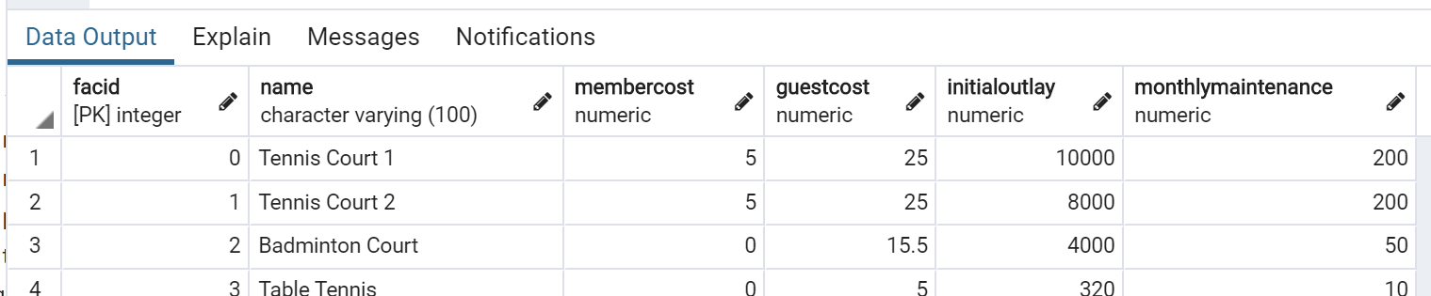

SELECT * FROM cd.facilities

1. You want to print out a list of all of the facilities and their cost to members. How would you retrieve a list of only facility names and costs?

SELECT name, membercost FROM cd.facilities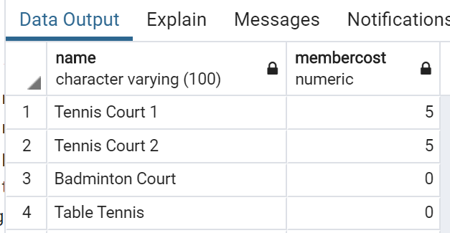

1. How can you produce a list of facilities that charge a fee to members?
   * Expected Results should have just 5 rows:
   * 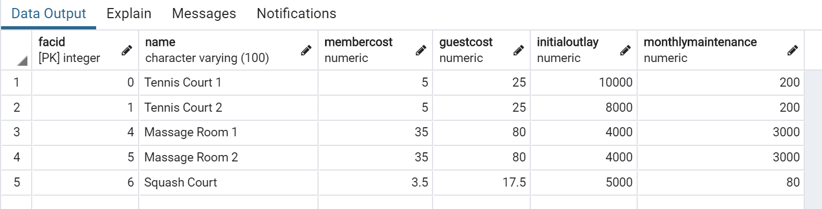

SELECT * FROM cd.facilities

WHERE membercost != 0

1. How can you produce a list of facilities that charge a fee to members, and that fee is less than 1/50th of the monthly maintenance cost? Return the facid, facility name, member cost, and monthly maintenance of the facilities in question.
   * Result is just two rows:

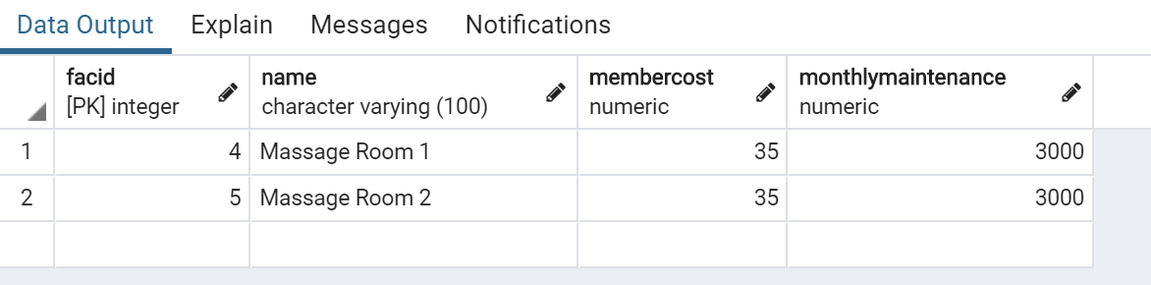

SELECT facid, name, membercost, monthlymaintenance FROM cd.facilities

WHERE membercost < (monthlymaintenance / 50)

AND membercost != 0

1. How can you produce a list of all facilities with the word 'Tennis' in their name?
   * **Expected Result is 3 rows**
   * 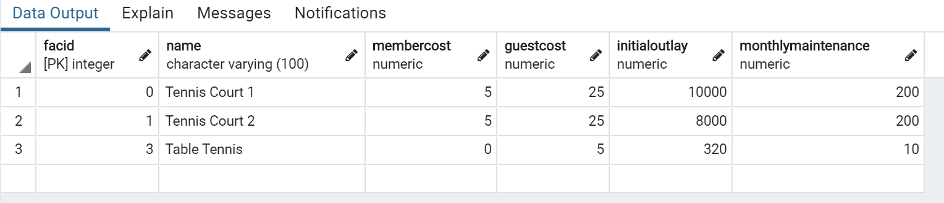

SELECT * FROM cd.facilities

WHERE name ILIKE '%tennis%'

1. How can you retrieve the details of facilities with ID 1 and 5? Try to do it without using the OR operator.
   * **Expected Result is 2 rows**
   * 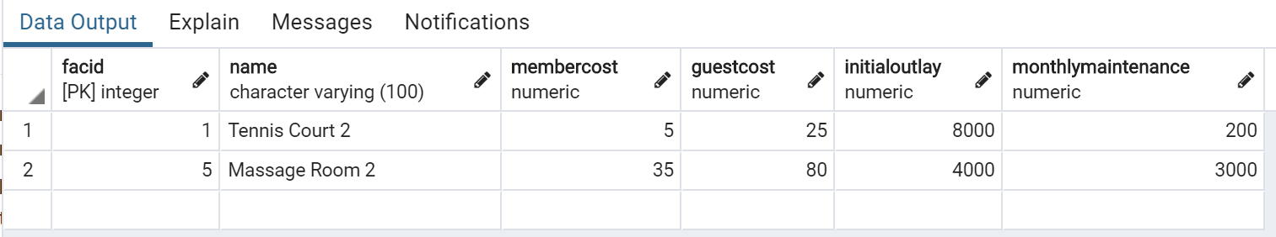

SELECT * FROM cd.facilities

WHERE facid IN (1, 5)

1. How can you produce a list of members who joined after the start of September 2012? Return the memid, surname, firstname, and joindate of the members in question.
   * **Expected Result is 10 rows (not all are shown below)**
   * 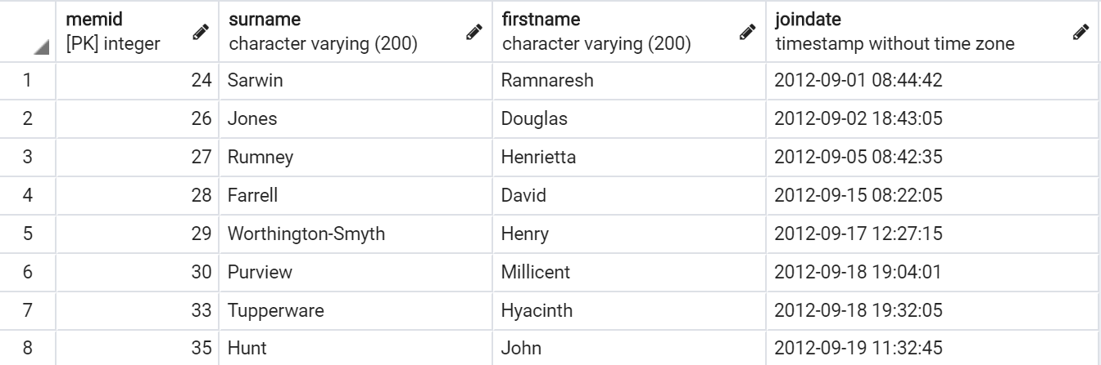

SELECT memid, surname, firstname, joindate FROM cd.members

WHERE joindate >= '2012-09-01'

1. How can you produce an ordered list of the first 10 surnames in the members table? The list must not contain duplicates.
   * **Expected Result should be 10 rows if you include GUEST as a last name**
   * 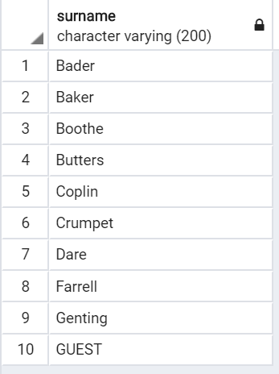

SELECT DISTINCT(surname)

FROM cd.members

ORDER BY surname

LIMIT 10

1. You'd like to get the signup date of your last member. How can you retrieve this information?
   * **Expected Result**
   * **2012-09-26 18:08:45**

SELECT joindate

FROM cd.members

ORDER BY joindate DESC

LIMIT 1

1. Produce a count of the number of facilities that have a cost to guests of 10 or more.
   * **Expected Result**
   * **6**

SELECT COUNT(*)

FROM cd.facilities

WHERE guestcost >= 10

1. Produce a list of the total number of slots booked per facility in the month of September 2012. Produce an output table consisting of facility id and slots, sorted by the number of slots.
   * **Expected Result is 9 rows**
   * 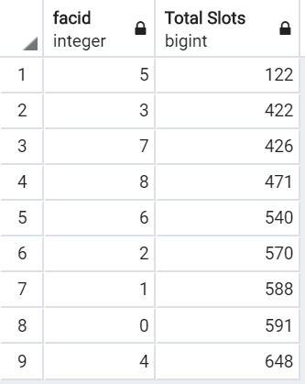

SELECT facid, SUM(slots) AS "Total Slots"

FROM cd.bookings

WHERE starttime BETWEEN '2012-09-01' AND '2012-10-01'

GROUP BY facid

ORDER BY SUM(slots)

1. Produce a list of facilities with more than 1000 slots booked. Produce an output table consisting of facility id and total slots, sorted by facility id.
   * **Expected Result is 5 rows**
   * 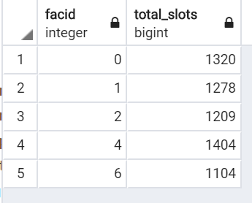

SELECT facid, SUM(slots) AS total_slots FROM cd.bookings

GROUP BY facid

HAVING SUM(slots) > 1000

ORDER BY facid

1. How can you produce a list of the start times for bookings for tennis courts, for the date '2012-09-21'? Return a list of start time and facility name pairings, ordered by the time.
   * **Expected Result is 12 rows**
   * 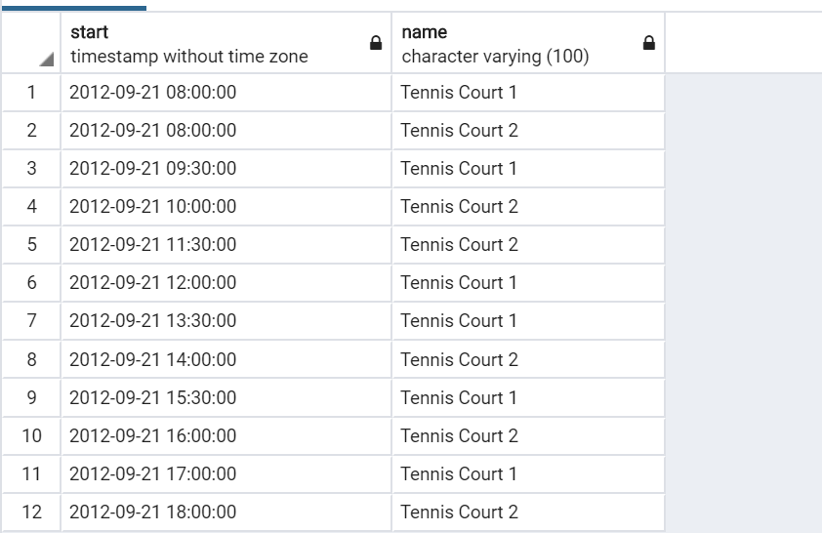

SELECT starttime AS start, name

FROM cd.bookings AS t1

INNER JOIN cd. facilities AS t2

ON t1.facid = t2.facid

WHERE t1.starttime BETWEEN '2012-09-21' AND '2012-09-22'

AND name ILIKE '%tennis court%'

ORDER BY t1.starttime

1. How can you produce a list of the start times for bookings by members named 'David Farrell'?
   * **Expected result is 34 rows of timestamps**

SELECT starttime

FROM cd.bookings AS t1

INNER JOIN cd.members AS t2

ON t1.memid = t2.memid

WHERE t2.firstname = 'David'

AND t2.surname = 'Farrell'

Result: 14/14 correct

#### Assessment Test 3

Welcome to your final assessment test! This will test your knowledge of the previous section, focused on creating databases and table operations. This test will actually consist of a more open-ended assignment below:

**Complete the following task:**

Create a new database called "School" this database should have two tables: **teachers** and **students.**

The **students** table should have columns for student_id, first_name,last_name, homeroom_number, phone,email, and graduation year.

The **teachers** table should have columns for teacher_id, first_name, last_name,

homeroom_number, department, email, and phone.

The constraints are mostly up to you, but your table constraints do have to consider the following:

1. We must have a phone number to contact students in case of an emergency.
2. We must have ids as the primary key of the tables
3. Phone numbers and emails must be unique to the individual.

Once you've made the tables, insert a student named Mark Watney (student_id=1) who has a phone number of 777-555-1234 and doesn't have an email. He graduates in 2035 and has 5 as a homeroom number.

Then insert a teacher names Jonas Salk (teacher_id = 1) who as a homeroom number of 5 and is from the Biology department. His contact info is: jsalk@school.org and a phone number of 777-555-4321.

**Keep in mind that these insert tasks may effect your constraints!**

CREATE TABLE students (

student_id SERIAL PRIMARY KEY,

first_name VARCHAR,

last_name VARCHAR,

homeroom_number VARCHAR,

phone VARCHAR NOT NULL UNIQUE,

email VARCHAR UNIQUE,

graduation_year VARCHAR

);

CREATE TABLE teachers (

teacher_id SERIAL PRIMARY KEY,

first_name VARCHAR,

last_name VARCHAR,

homeroom_number VARCHAR,

department VARCHAR,

email VARCHAR UNIQUE,

phone VARCHAR UNIQUE

);

INSERT INTO students(

student_id,

first_name,

last_name,

homeroom_number,

phone,

graduation_year

) VALUES (

1,

'Mark',

'Watney',

'5',

'777-555-1234',

'2035'

);

INSERT INTO teachers (

teacher_id,

first_name,

last_name,

homeroom_number,

department,

email,

phone

) VALUES (

1,

'Jonas',

'Salk',

'5',

'Biology',

'jsalk@school.org',

'777-555-4321'

)

Note: I didn’t add VARCHAR lengths due to this not being used in any production and because it doesn’t impact performance much according to this: <https://dba.stackexchange.com/questions/20974/should-i-add-an-arbitrary-length-limit-to-varchar-columns>

Result: 4/4 correct

**Conditional Expressions and Procedures challenge**

Q: Display the sum of film ratings individually

A: SELECT

SUM(CASE rating

WHEN 'NC-17' then 1

ELSE 0

END) AS "sum NC-17",

SUM(CASE rating

WHEN 'G' then 1

ELSE 0

END) AS "sum G",

SUM(CASE rating

WHEN 'PG' then 1

ELSE 0

END) AS "sum PG",

SUM(CASE rating

WHEN 'PG-13' then 1

ELSE 0

END) AS "sum PG-13",

SUM(CASE rating

WHEN 'R' then 1

ELSE 0

END) AS "sum R"

FROM film